USER REQUIREMENTS SPECIFICATION

TASK MANAGEMENT SYSTEM
OF
MIS DEPARTMENT

HEALTHCARE PHARMACEUTICALS LTD.


Table of Contents

1. Introduction
1.1 Purpose
1.2 Project Background
1.3 Business Objectives
1.4 Project Scope
1.5 Project Objectives

2. Identified Risks, Assumptions & Constraints
2.1 Identified Risks
2.2 Assumptions
2.3 Constraints

3. Proposed System Overview
3.1 System Description (Single Page Workflow)
3.2 System User Profile (Admin, Project Manager, Employee)
3.3 High-level System Diagram / Context

4. Future Business Processes
4.1 Creation of New Project
4.2 Creation of New Module under Project
4.3 Task Creation and Assignment
4.4 Task Drafting and Editing before Submission
4.5 Task Tracking and Status Updates
4.6 Notifications & Deadline Alerts

5. Functional Requirements
5.1 User & Role Management
5.2 Project Management
5.3 Module Management
5.4 Task Management (with Draft Option)
5.5 Task Assignment (multi-user support)
5.6 Filtering & Search (by project, module, task, employee, status, deadline)
5.7 Dashboard & Status Tracking
5.8 Notifications (in-app alerts, deadlines)

6. Non-Functional Requirements
6.1 Performance (Load time & Response time)
6.2 Audit, Control & Security
6.3 Global Business Rules
6.4 Data Requirements
6.5 Usability Requirements
6.6 Service Level Targets
6.7 Data Growth & Retention
6.8 Number of Users & IT Equipment Requirements

8. Appendices
8.1 Business Process Diagrams (Use Case & Flowcharts)
8.2 Data Requirements Table
8.3 Reference Documents
8.4 Glossary of Terms

- INTRODUCTION
1.1 Purpose
This document defines the User Requirement Specification (URS) for the Task Management System (TMS). The purpose of this URS is to capture the business needs and user expectations for a centralized platform to manage projects, modules, and tasks effectively.
The requirements described in this document will serve as the foundation for system design, implementation, and validation.

1.2 Project Background
Currently, project and task tracking is managed through a combination of spreadsheets, emails, and manual follow-ups. This results in:
- Lack of centralized visibility of project progress.
- Delays in task assignments and tracking.
- Difficulty in monitoring deadlines and responsibilities.
- No structured way to manage drafts or iterative updates before final submission.
The Task Management System aims to resolve these issues by introducing a Web Application that enables real-time task management with role-based access and intuitive workflows.

1.3 Business Objectives
The high-level business objectives of the Task Management System are:
- Provide a centralized platform for managing projects, modules, and tasks.
- Improve collaboration through role-based dashboards and task assignments.
- Enable seamless draft management for projects, modules, and tasks.
- Enhance visibility with real-time dashboards and progress tracking.
- Reduce delays by implementing in-app notifications and deadline alerts.
- Improve efficiency by enabling filtering, searching, and reporting.

1.4 Project Scope
The Task Management System will include:
- User and role-based access (Admin, Project Manager, Employee).
- End-to-end workflow covering Project → Module → Task → Assignment.
- Draft functionality for incomplete records.
- Real-time status tracking and dashboard visualization.
- In-app notifications for assignments and approaching deadlines.
The system will not initially include:
- Mobile application (future enhancement).
- Third-party integrations (export/import with external apps).

1.5 Project Objectives
The project objectives are to:
- Automate manual processes for project and task tracking.
- Improve accountability through transparent task ownership.
- Provide management with clear progress tracking at project, module, and task levels.
- Offer user-friendly features like inline editing, dynamic dropdowns.
- Ensure system security, scalability, and high performance.

2. IDENTIFIED RISKS, ASSUMPTIONS & CONSTRAINTS
2.1 Identified Risks
The following risks may affect the Task Management System (TMS):
No. | Risk Description | Likelihood | Mitigation
1 | Users may resist switching from manual/spreadsheet-based systems to the new platform. | Medium | Provide training, user guides, and pilot testing.
2 | Delays in system rollout due to unclear requirements from stakeholders. | Medium | Conduct requirement workshops and confirm sign-off early.
3 | Limited technical resources may delay project implementation. | Medium | Assign backup resources and adopt phased rollout.
4 | Security risks if proper access controls are not enforced. | Low | Enforce role-based access and strong password encryption.
5 | Excessive notifications may overwhelm users. | Medium | Provide user-configurable notification settings.
2.2 Assumptions
- All users (Admin, Project Manager, Employee) will have access to a stable internet connection and modern browsers (Chrome, Firefox, Edge).
- The system will be deployed as a standard web application.
- The system will primarily be used on desktop/laptop devices.
- End-users will participate in UAT and provide timely feedback.
- Training sessions and supporting documents will be provided before rollout.

2.3 Constraints
- The system must follow the organization’s IT policies and data security regulations.
- System must use existing IT infrastructure and approved technologies.
- User registration will be limited to Admin-managed employees only (no public signup).
- Initial version will support only English language (multi-language in future).
- System performance should allow page loading and navigation within 3–4 seconds.

3. PROPOSED SYSTEM OVERVIEW
3.1 System Description
The Task Management System (TMS) is a web-based application designed to streamline project, module, and task management within the organization.
It will provide:
- Centralized project and task tracking.
- Role-based access (Admin, Project Manager, Employee).
- Real-time status updates of projects, modules, and tasks.
- Draft functionality to allow saving incomplete records for later editing.
- Notifications for task assignments and approaching deadlines.
The system is intended to replace manual/spreadsheet-based tracking with an integrated platform, ensuring better collaboration, visibility, and accountability.

3.2 System User Profile
The following user roles will be supported in the system:
Role | Responsibilities
Admin | Registers employees, manages user roles, controls system settings.
Project Manager | Creates projects, modules, and tasks; assigns tasks; tracks progress.
Employee | Views assigned tasks, updates task status, uploads attachments, collaborates with team.

3.3 High-Level System Context
The TMS will operate as a centralized system accessible through web browsers. The following interactions are expected:
- Admin manages user access and overall system configuration.
- Project Managers create projects and modules, and assign tasks to employees.
- Employees receive notifications for assignments and update task progress.
- System maintains records of projects, modules, tasks, drafts, and status updates.
- Optional Future Scope: Export filtered data as CSV/PDF for reporting purposes.

4. FUTURE BUSINESS PROCESSES
The Task Management System (TMS) will introduce structured business processes to replace manual tracking and improve collaboration. The key processes are described below.

4.1 List of Future Business Processes
Process ID | Business Process Title
BP-001 | Creation of New Project
BP-002 | Creation of Module under Project
BP-003 | Task Creation
BP-004 | Task Assignment
BP-005 | Task Status Update & Tracking
BP-006 | Notifications & Alerts

4.2 BP-001 – Creation of New Project
- A Project Manager creates a new project by entering Project Name and Description.
- The project is saved and becomes available in the project list.
- Admin and Project Managers can view all projects, while Employees see only assigned ones.

4.3 BP-002 – Creation of Module under Project
- Once a project is created, the Project Manager can create one or more modules under it.
- Module details include Module Name and Description.
- Modules are linked to their respective projects for structured tracking.

4.4 BP-003 – Task Creation
- Tasks are created under a selected module.
- Task details include Title, Description, Start Date, End Date, and assignment.
- Tasks can be created in a draft state (optional) but must be finalized before assignment.

4.5 BP-004 – Task Assignment
- Project Managers assign tasks to one or multiple employees.
- Notifications are sent to employees upon assignment.
- Assigned tasks appear in employees’ dashboards.

4.6 BP-005 – Task Status Update & Tracking
- Employees can update task status as In Progress or Completed.
- Managers track overall progress at project, module, and task levels through dashboards.
- System displays status indicators for each item (Not Started, In Progress, Completed).

4.7 BP-006 – Notifications & Alerts
- System generates in-app notifications for new assignments or updates.
- Deadline reminders are triggered as tasks approach due dates.
- Notifications are visible on the dashboard for quick action.
5. FUNCTIONAL REQUIREMENTS
The following functional requirements describe the core capabilities of the Task Management System (TMS).

5.1 User & Role Management
- The system shall support role-based access (Admin, Project Manager, Employee).
- The Admin shall be able to register employees and assign roles.
- The system shall redirect users to a role-specific dashboard after login.
- Users shall be able to manage their profiles (update information, change password).

5.2 Project Management
- Project Managers shall be able to create new projects by entering name and description.
- The system shall maintain a list of projects for selection when creating modules.
- Projects shall be viewable based on user roles (Admins & Project Managers: all projects; Employees: only assigned).

5.3 Module Management
- Project Managers shall be able to create one or more modules under a selected project.
- Modules shall include name, description, and remarks.
- Modules shall be displayed under their respective project in the dashboard.

5.4 Task Management
- Project Managers shall be able to create tasks under a selected module.
- Task details shall include title, start date, end date.
- The system shall provide a Save Changes option:
  - Any edits made to a project, module, or task shall be saved automatically.
  - Users can later access and continue from where they left off.
- Employees shall be able to update task status (Not Started → In Progress → Completed).

5.5 Task Assignment
- Project Managers shall be able to assign one or more employees to a task.
- The system shall display confirmation messages after successful assignment.
- Assigned tasks shall appear in employees’ dashboards automatically.

5.6 Filtering & Search
- Users shall be able to filter and search by: Project, Module, Task, Employee, Status, Deadline.
- Quick access shall be provided to view partially saved tasks for editing.
- Future scope: Export search results as CSV or PDF.

5.7 Dashboard & Status Tracking
- The system shall display a hierarchical view: Project → Module → Task.
- Each item shall show a status indicator (In Progress, Completed).
- Project Managers shall be able to view overall project progress.
- Employees shall see only their assigned tasks.

5.8 Notifications
- The system shall provide in-app notifications for task assignments and updates.
- Alerts shall be generated for approaching deadlines.
- Notifications shall appear in the user dashboard.

6. NON-FUNCTIONAL REQUIREMENTS
The non-functional requirements specify the performance, security, usability, and operational standards that the Task Management System (TMS) must meet.

6.1 Performance Requirements
- The system shall load the login and dashboard pages within 3–4 seconds under normal network conditions.
- The system shall support at least 100 concurrent users without performance degradation.
- Search and filtering operations shall return results within 3 seconds for standard datasets.

6.2 Audit, Control & Security
- The system shall require unique user credentials (username and password) for login.
- Passwords shall be encrypted using industry-standard hashing algorithms.
- The system shall maintain an audit log of user activities (login/logout, creation/updates of projects, tasks, assignments).
- Access rights shall be strictly controlled by role-based permissions.
- Backup and recovery procedures shall be implemented to prevent data loss.

6.3 Global Business Rules
- Only Admin can register employees and assign roles.
- Each project must have at least one module before tasks can be created.
- Each task must have a start date and an end date.
- Users may only see projects, modules, and tasks relevant to their role and assignments.

6.4 Data Requirements
- The system shall store project, module, and task information in a secure database.
- Attachments (PDFs, images, documents) shall be stored and linked to their respective tasks.
- All date fields shall store both date and time.
- Deleted records shall not be permanently erased but marked as inactive for audit purposes.

6.5 Usability Requirements
- The system shall have a clean and intuitive interface for ease of use.
- Labels, messages, and navigation shall be clear and consistent.
- A help/manual section shall be available for users.
- Users shall be able to save changes at any time without losing progress.
- Notification alerts shall be simple and non-intrusive.

6.6 Service Level Targets
- System availability shall be at least 99.5% during working hours (Mon–Sat, 8:30 AM – 6:00 PM).
- Scheduled maintenance shall occur outside normal working hours.
- Data loss tolerance shall be limited to the current day’s transactions in case of system failure.

6.7 Data Growth & Retention
- The system shall support an expected 10% annual growth in data.
- Completed or old tasks may be archived after 3 years but retrievable when needed.
- Audit logs shall be retained for at least 1 year before archival.

6.8 Number of Users & IT Equipment Requirements
- The system shall initially support 100 users, with scalability to 300 users.
- Users will primarily access the system via desktop/laptop browsers.
- No dedicated mobile application is included in the current scope (future enhancement).

7. SYSTEM IMPLEMENTATION CONSIDERATIONS

7.1 Implementation Strategy
- The system will be deployed using a rollout approach, where all users transition to the new system at once.
- No parallel run with spreadsheets/manual processes will be maintained, except for backup during the initial week of rollout.
- A pilot phase may be conducted with a small group of Project Managers and Employees before organization-wide release.

7.2 Transition Approach
- Existing ongoing projects and tasks may be manually entered into the system at the time of rollout.
- Historical data (previously completed tasks/projects) will not be migrated but can be stored offline for reference.
- Change management activities, including workshops and training, will ensure smooth adoption by end-users.

7.3 Data Migration & Conversion
- Since no previous digital task management system exists, data migration will be minimal.
- Only active projects and tasks from manual records (spreadsheets, emails) will be imported at rollout.
- Project Managers will be responsible for entering the initial set of data into the system.

7.4 Training Approach
- Training will be provided for all roles (Admin, Project Manager, Employee).
- Training methods will include:
  - Workshops for Project Managers and Admins.
  - Short tutorial videos for Employees.
  - A user manual/help guide accessible directly in the system.
- Post-rollout, ongoing user support will be provided via the IT helpdesk.

7.5 Support & Maintenance
- A designated System Administrator will manage technical support, role management, and troubleshooting.
- Regular updates (bug fixes, minor enhancements) will be deployed as needed.
- Feedback from users will be collected to identify future improvements (e.g., mobile app, reporting features).

8. APPENDICES
8.1 Business Process Diagrams
- Use Case Diagrams
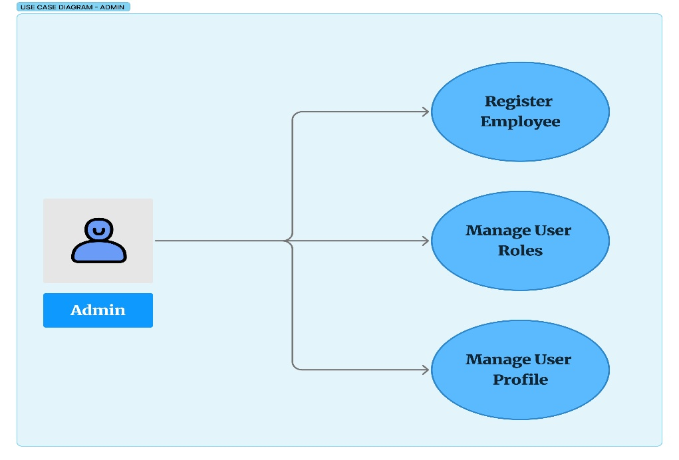
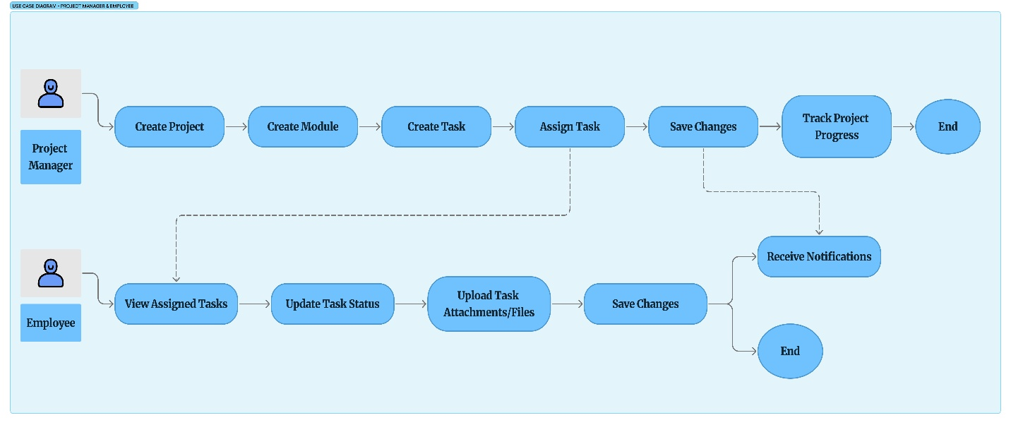
- Process Flowcharts:

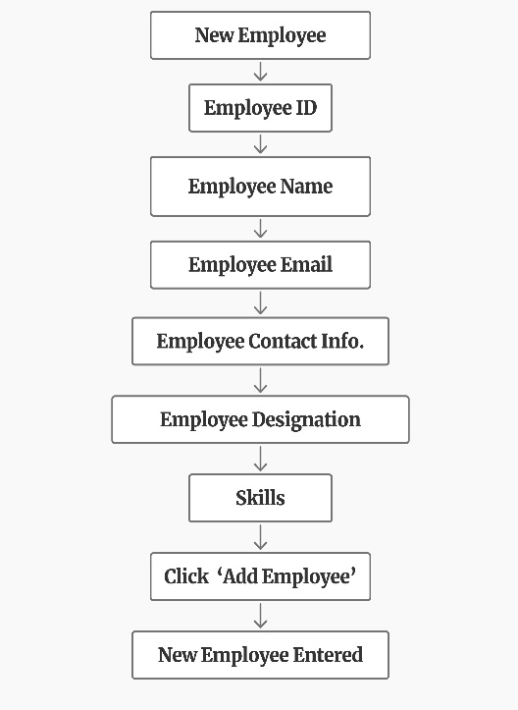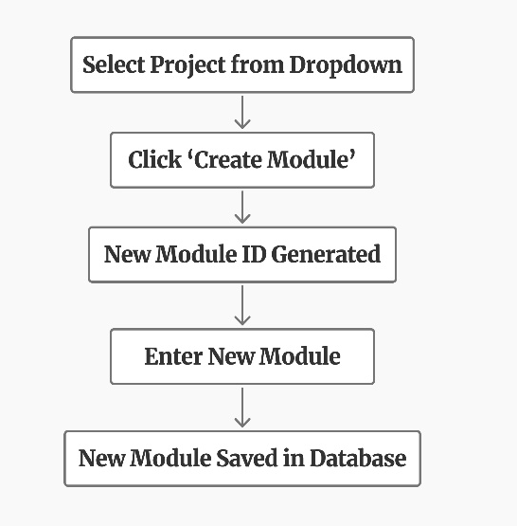
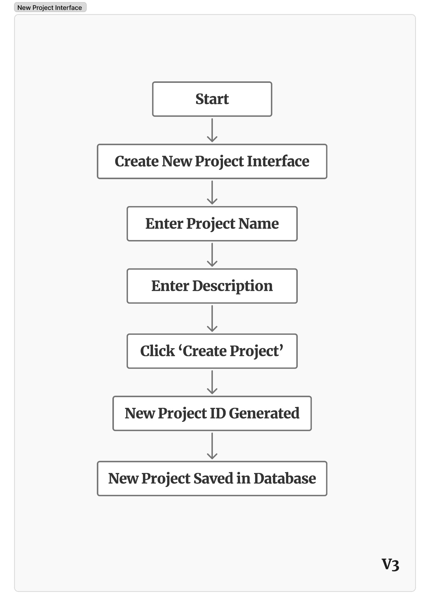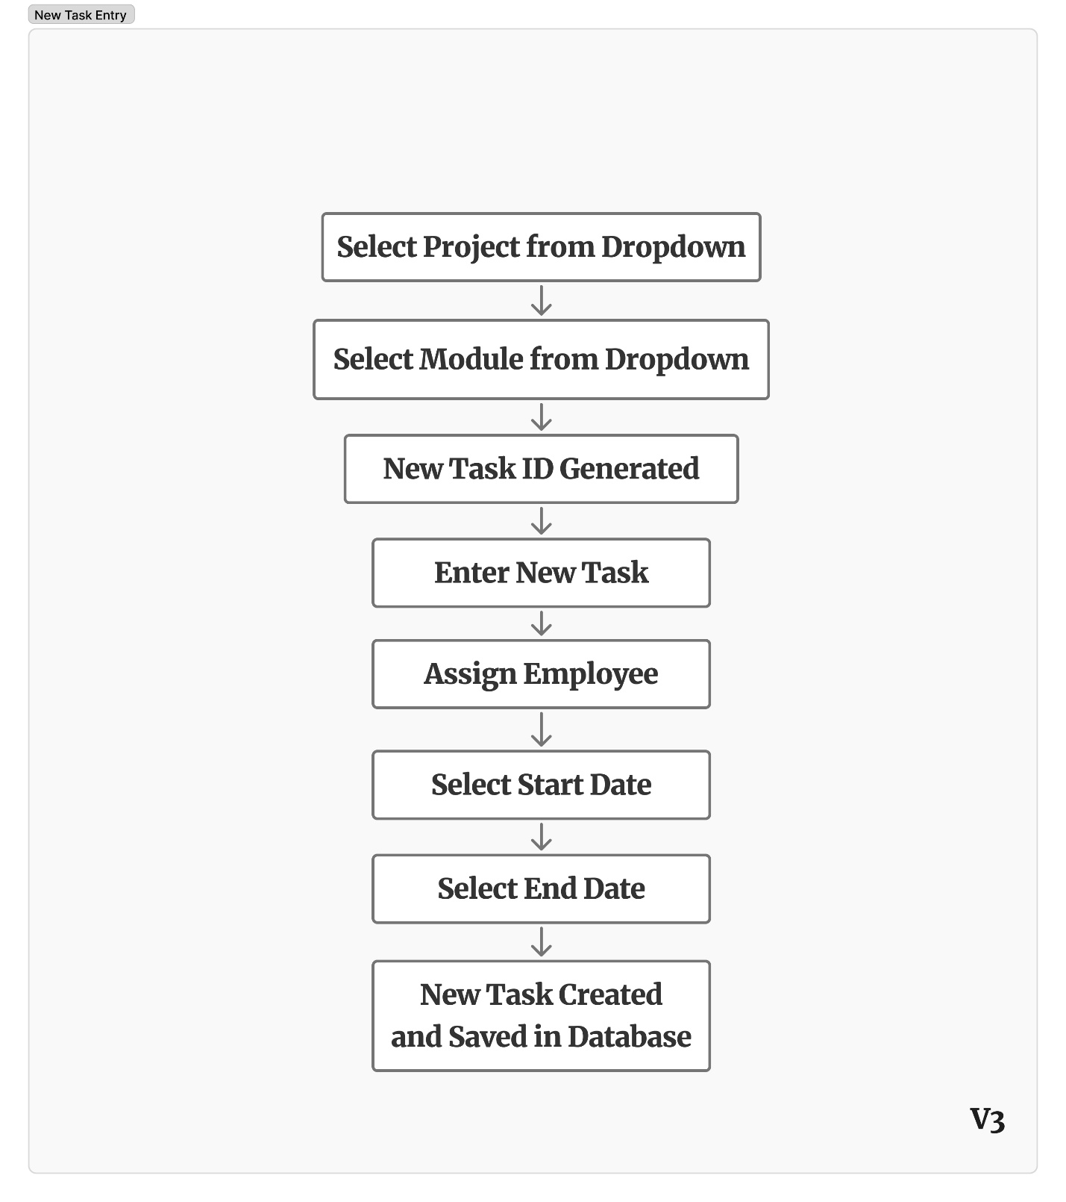
8.2 Data Requirements Table
Key data elements for the TMS include:
Data Entity | Key Attributes
Project | Project ID, Project Name, Description, Created By, Created Date
Module | Module ID, Module Name, Description, Linked Project ID
Task | Task ID, Title, Description, Start Date, End Date, Assigned Employees, Status, Attachments
User | User ID, Name, Role (Admin/Project Manager/Employee), Department, Contact Information
Notification | Notification ID, Message, Type (Assignment/Deadline), Recipient User ID, Timestamp

8.3 Reference Documents
- Organization’s IT Security Policies.
- Project Charter / Business Case (if available).
- Best Practices for Business Analyst – Appendix C (URS Template Reference).

8.4 Glossary of Terms
- Admin – User with full control over the system, responsible for user registration and access management.
- Project Manager – User responsible for creating projects/modules, assigning tasks, and tracking progress.
- Employee – User responsible for executing assigned tasks and updating status.
- Module – A logical subdivision of a project to organize tasks.
- Task – A unit of work assigned to one or more employees, with deadlines and status updates.
- Save Changes – Function allowing users to save progress on project/module/task edits and resume later.
- Dashboard – A visual interface showing project, module, and task progress.
- Notification – An in-app alert generated for task assignments or approaching deadlines.

